**Location Data Management**

LDM is dealing with service locations. Service location is a premise where we can establish a network connection.

 What is T18?

T18 is the name given to a set of tables that covers FDDD (Functional Detailed Design Document) and As Builts. The T18 contains tables that list all of the network elements and serviceable locations within a SAM. The T18 is created by the design partners (DPs) that work for Telstra (TLS). The purpose of this document is so that NBN is aware of what the network will be inside the SAM.

 So, the T18 comes from Telstra’s Design Partners. NBN then loads the location and network data into our systems so that we have a view of what the network looks like in the field.

What is LDMs role in the T18?

LDMs job is to ensure that all of the locations within the T18 are in our location database, in the correct location with unique identifier and that the address attributes are the same as the T18 file. If we do not ensure that all the locations in the T18 are in the database then the downstream teams will not be able to complete their network load.

**LDM Work Flow**

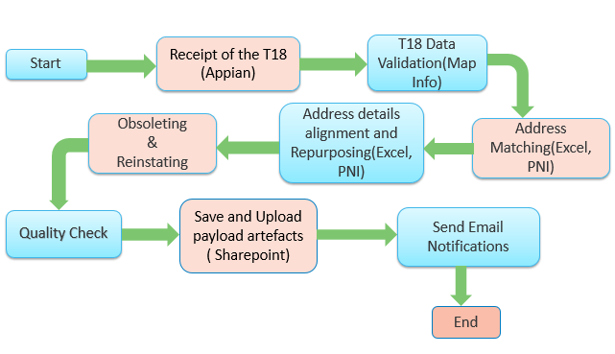

**T18 Data Validation**

Sl file in T18 package validated against 20 checks. All defects with Severity level should be collected in the feedback register. It is the feedback to Telstra and will be discussed in the triage Forum.

It is the view of the business that the T18 accurately reflects what is within the SAM so the T18 is a single source of truth. If we disagree with the single source of truth then this needs to be clarified with Telstra and if Telstra agrees they will provide a re-submission of the T18 so that there is a new single source of truth.

**Address Matching**

Process of replacing the temporary ID in the “id” column with the correct LOC ID. When adding/matching a record, the attributes need to be the same as Telstra's data in T18. If LOC ID has already been provided in the T18 unless it is disregarded do not reuse it, instead make a new record. We do not want duplicate LOC IDs, so it is best if you have the duplicate condition filter switched on in EXCEL so you are able to immediately spot duplicate LOC IDs. Make sure the LOC ID’s matching is in the correct parcel.

Save a copy of the LOC IDs that you have replaced with the corresponding Temporary ID and prepare Loc Id-Temp Id mapping file in csv format.

**Address Alignment & Repurposing**

Address alignment is the process of comparing and correcting the PNI address with T18 address for valid records. In cases where a location in the T18 is referring to a different location that we have in PNI/ELMS then we consider this repurposing the location. In addition to this perform following operations including Obsoleting and reinstating:

* Bulk export the locations within the SAM
* Exclude the out of scope boundaries from Bulk export
* Compare the LOC IDs from the T18 table with the Bulk Export table and align the address
* Repurposing cases found are populate to a new file in csv format.
* What is marked as Disregard and is not already Obsolete, change it to be so
* What is marked as Active and is obsolete, reinstate this address
* Change unmarketable addresses to marketable for all Active locations
* Change non premise flag to Y for all Active locations
* Change within city limits to Y for all Active locations
* Import the changes into PNI
* Bulk export the locations within the SAM
* Count the number of Active locations. This should be the same number of active locations in the T18 table.

**Quality Check**

Technology Comparison: Compare the technology type of locations present in SL with PNI. PNI technology can be extracted in a file, LOC ID extract report.

Layer Walk: As service location is a premise with an address, it should reside in a parcel. Layer walk process is used to Identify if any service locations are cascaded or if placed in the middle of road by brief scanning. We can move such locations to correct parcel as per the state map or google map

Appendix 1:

**Out of scope boundaries**:

* ASA (Adequately Serviced Area)
* MPS (Multi Premises Site) (only if in-service)
* NDS (New Development Stage) (If the location associated with Existing PCD, LDM can perform LOC ID Creation and Reinstating)
* ADA (Access Distribution Area) (only if in-service)
* HVMDU (High value MDU)

Appendix 2:

**LDM Scope for Partial Onsa**:

* Partial ONSA locations are which having is_partial_onsa flag as ‘Y’ in SL.
* Valid locations in the Partial ONSA are with equipment associated in sl or premise_passed_Telstra flag is ‘Y’.
* LOC ID creation to be performed by LMS
* LDM can reinstate the locations in PNI which are valid as per sl except out of scope boundaries

Appendix 3:

**ELMS**: Enterprise location management system, master database of NBN. We should validate the PNI address against the ELMS data. PNI to ELMS sync happens in the overnight. If any wrong update happens in PNI, it would not flow to ELMS. It will capture as Quarantine.

Automations

* **FBR Generation Tool**

21 T18 data validation checks are covered by this tool. Checks are validating using Mapinfo tool and feedback register generating using macro.

Tool input is sl in the T18 Package

* **LocID Allocation Tool**

LOC ID population to sl from PNI if address of temp ID matches with PNI address using macro tool.

Inputs are sl, Bulk export, ELMS Extract, HVMDU Report and MPS Export.

* **Address Alignment Tool**

This is a Macro tool and It will perform following:  
> Address alignment of addresses as per the specific checks  
> Need validation sheet will generate if any mismatches cannot be solved by tool along with repurposed cases. LDM team have to action upon that manually.  
> Perform Obsoleting and reinstating   
> Providing duplicate address sheet if any valid address duplicated in PNI

Inputs are Bulk export and Completed list

* **Final Validation Tool**

Completion mail table will generate using this macro tool